

**DCFabric SDN Controller**

**QuickStart Manual**

**Document number：**DCFabric SDN-Controller-QuickStart

**Document name：**Open DCFabric SDN Controller QuickStart Manual

**Version information：**V1.0.0

**Date created：**2017/05/03

**Last modified：**2017/05/03

# Revision record

|  |  |  |  |  |  |  |
| --- | --- | --- | --- | --- | --- | --- |
| **Version number** | **Reason for revision** | **Brief description（change content and scope of change）** | **Date** | **Change person** | **Approval date** | **Approval**  **person** |
| V0.1 | Create |  | 2017-05-03 | CaiyuanYang |  |  |
|  |  |  |  |  |  |  |
|  |  |  |  |  |  |  |
|  |  |  |  |  |  |  |
|  |  |  |  |  |  |  |
|  |  |  |  |  |  |  |

Reason for revision**：**create；

# Approval information

|  |  |  |  |  |  |
| --- | --- | --- | --- | --- | --- |
| **Ordinal** | **Approver** | **Role** | **Approval date** | **Signature** | **Notes** |
|  |  |  |  |  |  |
|  |  |  |  |  |  |
|  |  |  |  |  |  |
|  |  |  |  |  |  |
|  |  |  |  |  |  |

# Introduction

## Writing purpose

This paper aims at the Mininet network emulation, the auxiliary manager understands and is familiar with SDN controller quickly and uses this SDN controller to connect the management Openflow switch.

## Reader objects

Readers of this document are expected to include:

* Data Center SDN Controller development Project management and development related personnel
* System Requirements Group, System Architecture Group, System Design Group
* Administrator, operation and maintenance personnel➢

➢ ➢

## Document conventions

All descriptions of this manual apply to the x86 architecture 64-bit CentOS 6.5 version or x86 GNOS system, such as non-mandatory, the server for deploying the Datacenter SDN controller must not have a third-party service that deploys other non-OS own, otherwise it will be necessary to reassess whether the data center SDN Controller is installed properly compatible. The installation deployment server described below in this article defaults to this Convention.

If you encounter problems using this manual please contact the person concerned.

## Terms Definition

|  |  |  |
| --- | --- | --- |
| Terminology and abbreviations | Full spell | Explain |
| Java sdk | Java Software Development Kit | Java software development kit |
| Redis | Remote Dictionary Server | Redis database |
|  |  |  |

# Version compilation

## Get source code

1.Get SDN controller source from Github

|  |
| --- |
| git clone https://github.com/China863SDN/DCFabric.git |



2.Access to the download directory DCFabric, then access to the SDN controller source directory DCFabric-controller. The directory and file structure and corresponding descriptions are illustrated as below.

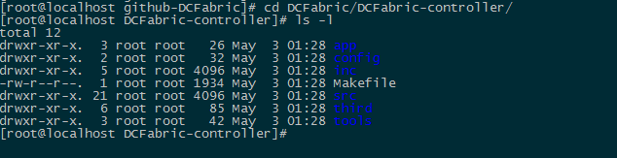

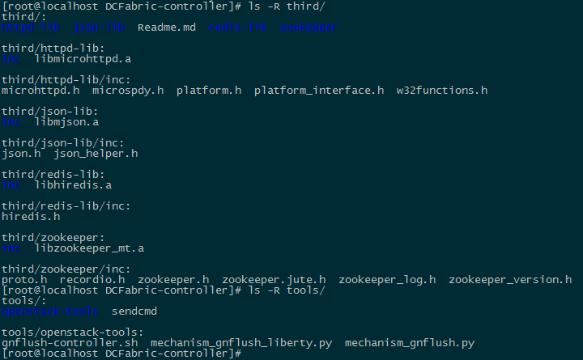

**app：**the directory is for application expand.developer can expand the application of DCFabric.

**inc：**the directory for header files, include .h files;

**src：**the directory for source files, include all .c files;

**third:** third tool

**redis-lib：**some header files and static library files releated to redis;

**httpd-lib：**some header files and static library files releated to http server;

**json-lib：**some header files and static library files releated to json;

**zookeeper：**some header files and static library files releated to zookeeper;

**tools：**the tools of docking openstack

**openstack-tools：**files required for installation,such as Openvswitch service startup script in each OpenStack Server node

## Compile Source code

1. Access to DCFabric-controller Directory，then clean old files which are made in compile process.



1. executing compilation

The debug version is generated by default compilation.if it is need to build release version,the command “make TYPE=release”is need to be executed and it can produced the executing file named DCFabric.If the version is debug,the executing file named DCFabric_debug is produced.

|  |
| --- |
| make TYPE=release |

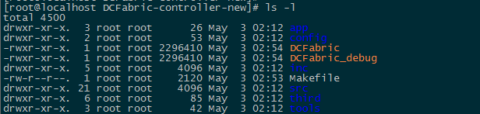

# Install deployment

## Jdk install

Get jdk installation package

It is need to get java sdk installation package jdk-7u65-linux-x64.tar.gz in 64bit linux system from oracle website and install before installing WEB APP. If linux system is 32bit operate system, it is need to choose 32bit java sdk installation package.

Extract jdk installation package

Access the directory where the installation package is in,then exact the JDK installation package.

|  |
| --- |
| tar -zxf jdk-7u65-linux-x64.tar.gz |



Install JDK into system directory.

|  |
| --- |
| mkdir –p /usr/lib/java-1.7.0/  mv jdk1.7.0_65 /usr/lib/java-1.7.0/  ln -s /usr/lib/java-1.7.0/jdk1.7.0_65/jre/lib/amd64/server/libjvm.so /usr/lib64/libjvm.so |

Configure java environment

Open the file /etc/profile by the command vi.

|  |
| --- |
| vi /etc/profile |

Add the following command at the bottom of the open file

|  |
| --- |
| export JAVA_HOME=/usr/lib/java-1.7.0/jdk1.7.0_65  export JRE_HOME=/usr/lib/java-1.7.0/jdk1.7.0_65/jre  export PATH=/lib64:$JAVA_HOME/bin:$JAVA_HOME/jre/bin:$PATH  export CLASSPATH=$CLASSPATH:.:$JAVA_HOME/lib:$JAVA_HOME/jre/lib |

After modifing the file /etc/profile, enter the following command to see if the current Java version number is "1.7.0_65" to determine whether the installation is successful:

|  |
| --- |
| source /etc/profile  ldconfig  java -version |

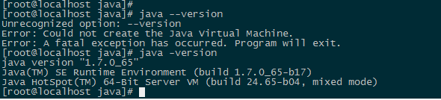

## Modify Configuration

View the file sdn_controller.conf in the directory config by vi tool and delete cluster_on mark in the section controller, or set cluster_on mark o equal 0;Delete openvstack_on mark in the section openvstack_conf, or set openvstack_on to equal 0; Inquiry the name of network interfaces, and modify manager_eth in the section controller.

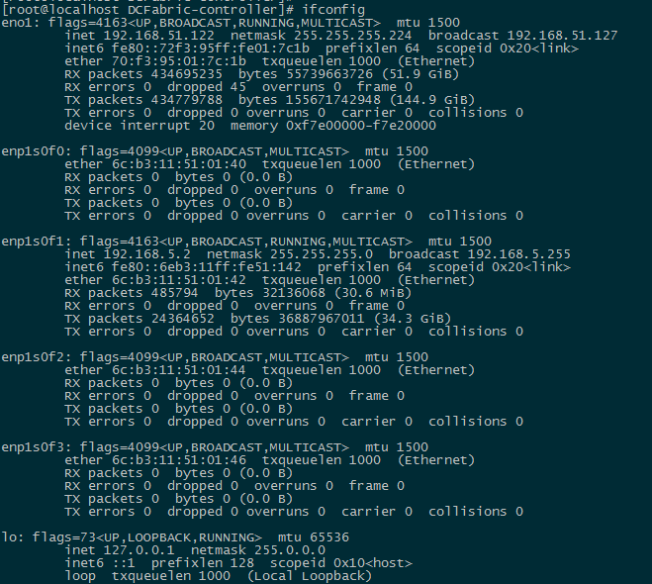

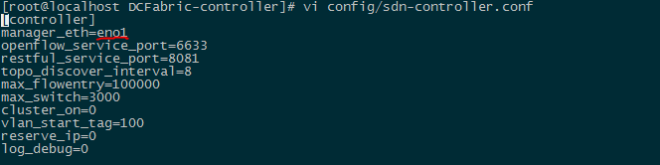

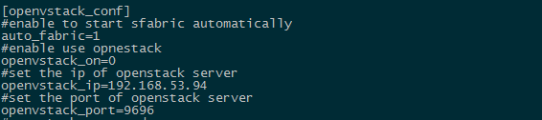

## Deploying Web

### Get WEB installation package

The installation package is consist of two parts: Tomcat installation package and SDN Controller Web App pack.[Download apache-tomcat-7.0.57.tar.gz installation package from the Apache Tomcat Web site](https://ssl.microsofttranslator.com/bv.aspx?from=&to=en&a=Download apache-tomcat-7.0.57.tar.gz installation package from the Apache Tomcat Web site" \t "http://www.bing.com/translator/_blank).Locate the SDN Controller Web App pack DCFabric-web in the DCFabric directory.

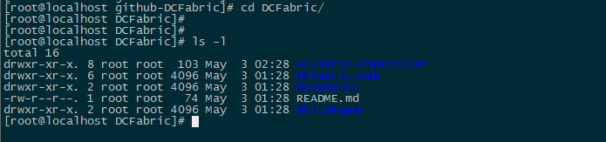

### Install Tomcat

Enter the "third" directory to extract the Tomcat installation package by executing the following command

|  |
| --- |
| tar -zxf apache-tomcat-7.0.57.tar.gz |

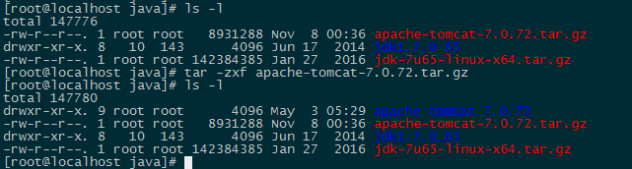

### Install WEB APP

Enter the DCFabric-web directory, copy the WebRoot installation package to the WebApps directory.

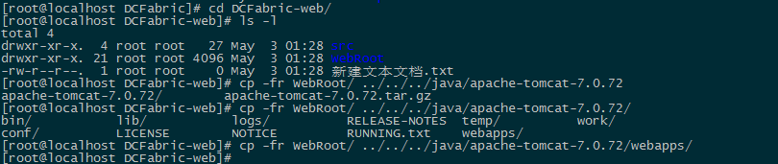

### Start WEB service

Enter the "apache-tomcat-7.0.57" directory and start Tomcat.

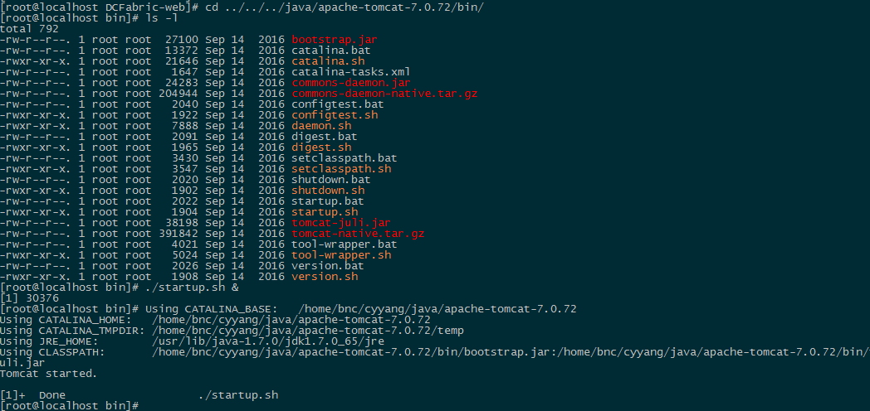

The web app can be accessed through the browser in the following URL format after startup（the default port of tomcat is 8080 and ServerIP is the IP address of SDN controller）：

|  |
| --- |
| http://ServerIP: Port/WebRoot/ |

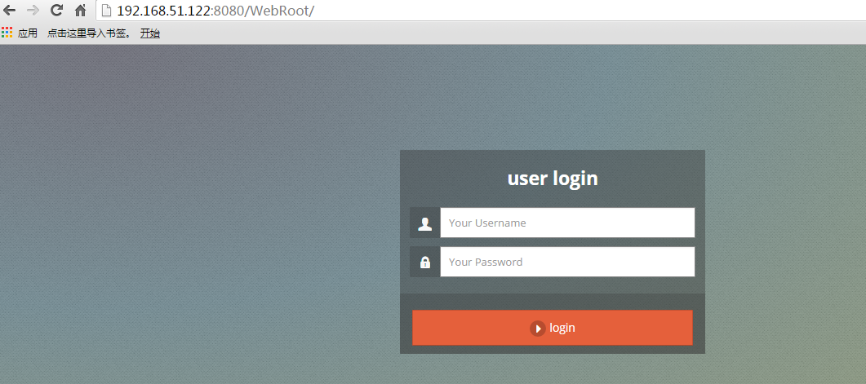

## Start program

Enter the DCFabric-controller directory, start the DCFabric program

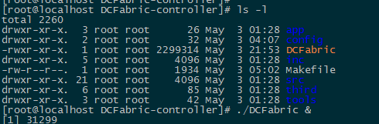

## View service

Use Netstat to view the 6633,6640 and 8081 ports to see if the service starts properly.

Netstat -anp

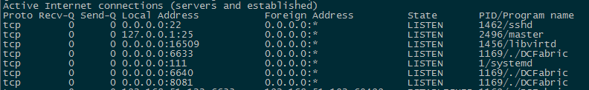

# **Network emulation**

## Install mininet

Mininet installation requires the Linux system to be one of Ubuntu,Debian,RedHat and Fedora, which currently does not support the CentOS system.Under the Ubuntu system, can be installed through Apt-get install Mininet or through the following source code.





## Dock controller

Set up the SDN controller IP and port through the OvS command and set up a simple switch and three hosts connected to the network environment through the mininet command, and test the network connectivity between the hosts through the Pingall command.

|  |
| --- |
| ovs-vsctl set-manager tcp:192.168.51.122:6640  mn --switch ovsk --controller=remote,ip=192.168.51.122,port=6633 --topo single,3 |



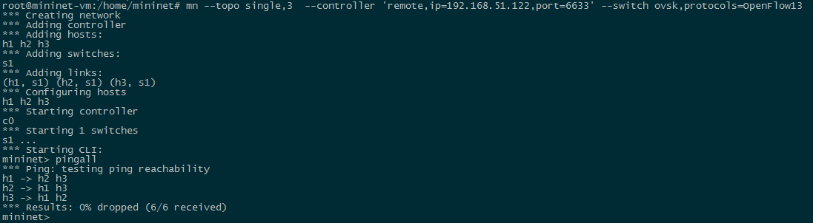

## View Topology

Login on the SDN Controller Web page and View the switch information and network topology information.

1 Use account “admin” and password “1234” to login on the web site http://ServerIP: Port/WebRoot/

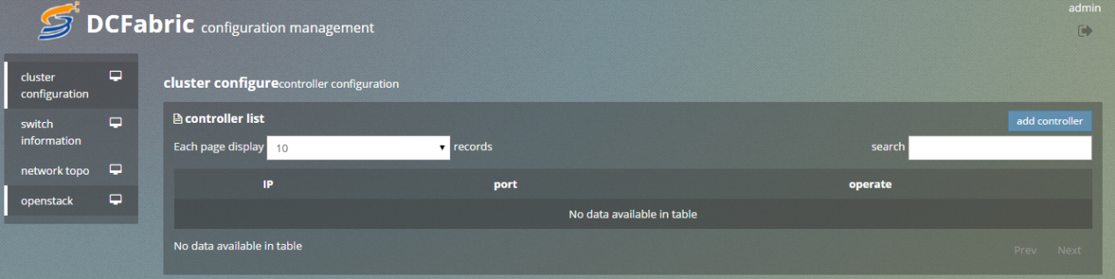

2 Click the button to add controller and enter the SDN controller IP and 8081 port.

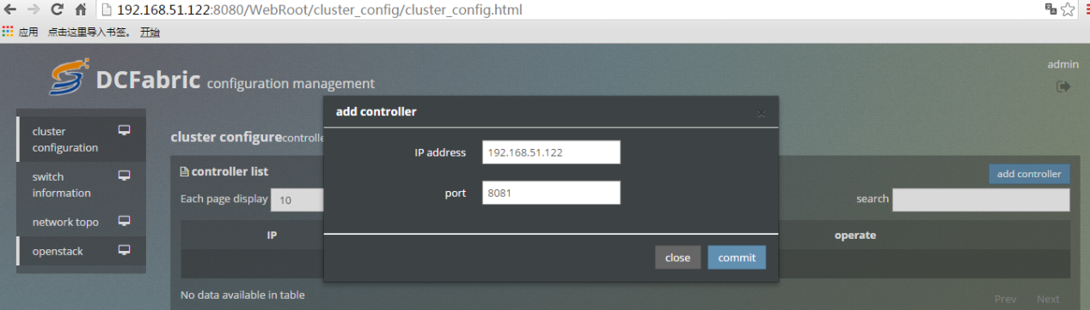

3 Click on the switch information, and then click the right query button to inquire switch information with the SDN controller connected

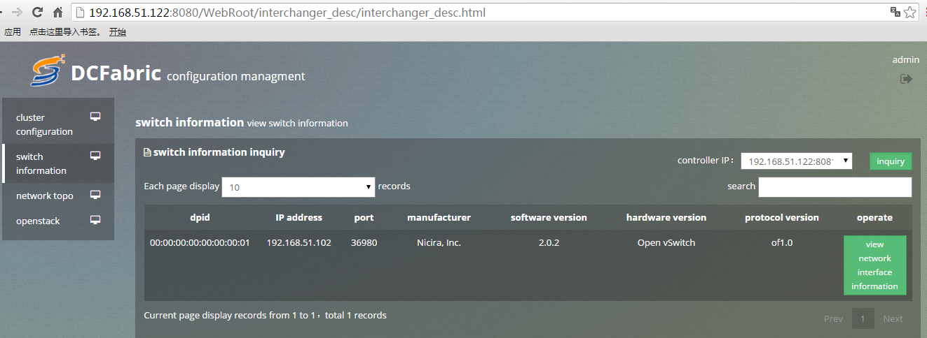

4 Click Network topology, query network topology map

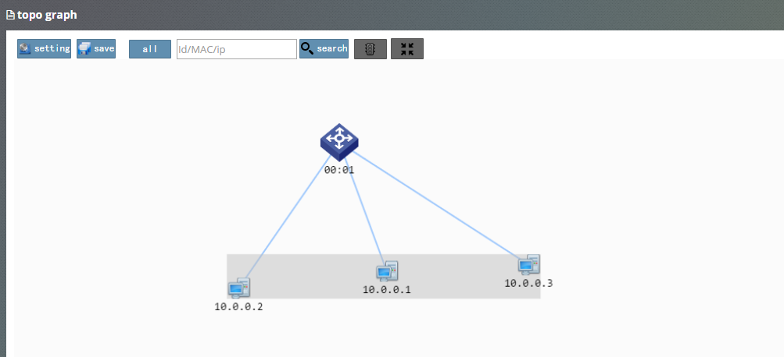

# FAQ

## Controller failed to start successfully

### 1 Problem description：

Failed to get interface information when controller start up



### Reason analysis：

There are some problem with the network interface and it needs to modify the configuration file about the part of network management port Manager_eth.

### 2 Problem description：

Service starts up failed when controller is started.

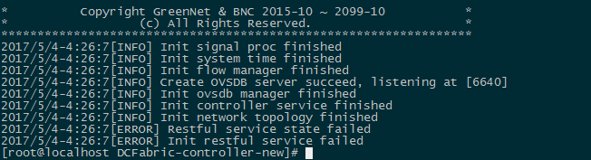

### Reason analysis：

The SDN controller program has been started on the device，it can be viewed by executing the command “ps -e | grep DCFabric”.



The old SDN controller program can be killed by executing the command ”kill -9 pid”,then start the new SDN controller program.

## Switch can not connect properly

### Problem description：

There are no new switches connecting to controller on the switch topology map.

### Reason analysis：

**1** Maybe The firewall is started,and it cause that the switches can’t connect controller.It can be sure whether the switches connecting to controller or not by executing the command “netstat -anp|grep 6633”



2 Maybe the switch connections reach the maximum number and the new switch connection can’t be accepted.

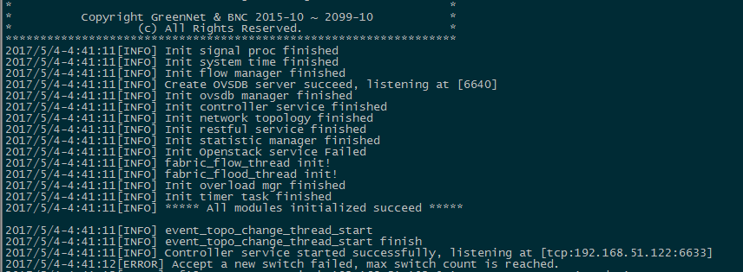

### Solution：

1 Turn off the firewall or use Iptables to open the three specific port such as 6633/6640/8081



